Framework for the space interaction in Ambient Intelligence Environment

Chang Ok Yun*, Gil Rim Choi**, Hang Joon Kim***, Tae Soo Yun****

*Arcade Game Regional Innovation Center, Dongseo University
47 Jurye-ro, Sasang-gu, Busan 47011, Korea
coyun@hanmail.net

**Subdivision of Computer Engineering, KyungNam College of Information & Technology
55, Centum jungang-ro, Haeundae-gu, Busan, 48058, Korea
grchoi2000@nate.com

**School of Computer Science and Engineering, Kyungpook National University,
80 Daehakro, Bukgu, Daegu 41566 Korea
kimhj@knu.ac.kr

****Division of Digital Contents, Dongseo University
47 Jurye-ro, Sasang-gu, Busan 47011, Korea
yntaesoo@gmail.com

Abstract

Interaction paradigm is composed of a special device, computing environment, and human’s ability. Most studies are focused on the input devices and output restrict displays and then they offer some restricted conditions and environments. In addition, most researches were not based on interaction space environment, but just be fixed the interaction environment by input devices or the output results. The smart interaction environment is needed for users and designers by designing environmental and space based interaction, out of input/output based interaction paradigm. Thus, this paper suggests a patten for space based interaction designing, and gives a guideline to designers. It analyzes existing interaction system in the interaction system, then, designs an interaction framework. It gives a guidelines to designers to design interaction based on the space with framework based technologies. It gives an ideal interaction environment through some examples with the guidelines. In this paper, make the users get desired information in ease by supplying suitable space based interaction environment in smart interaction. In various interaction ways, this kind of smart interaction make users to get information easily by focusing on the spaces not on the input devices, then user could make human affinity interaction in the space. In other words, it supplies smart interaction system to users by space based designing.

Keywords-Ubiquitous Computing; HCI; Ambient Intelligence; Smart Interaction; Space-centric; Framework

I. Introduction

Recently, most of the HCI study naturally utilizing human skills and capabilities over the life of the development in the physical world. It has been developed to vary the interaction between humans and computers to the technological advancement. In general, interaction paradigm has been centered around the made around the device, computing environment and human. Most of the paradigm is also operated by the technology rather than the starting point for this interaction space environment. In other words, the interaction environment is determined according to the interaction input devices. Interaction interface provides an intuitive interaction that controls the digital information in the virtual world after the user directly operated the object in the real world. These interfaces provide interactivity using a puck or a physical object[1, 2] in the projector-based environment. The research has already been done on the interaction interface[4] with the user's tactile multi-interaction techniques[3] and user interaction space of gesture recognition techniques[5,6] using image recognition sensors and motion sensors. There is also a variety of studies, such as a ubiquitous computing research interface to LCD-based projector[7,8]. Study on the existing interaction are the user has restricted or limitations on access to the input and displays. There have been many studies done around the device interaction technology.
In this paper, we propose an interaction framework by analyzing the intelligence ecology interactions through the organic relationship of interaction between properties. This paper presents the design and modeling ecosystem interactions by dividing the real and virtual interaction devices based approach as opposed to the typical device-centric approach. A variety of space-centric design methods for smart interactions are necessary to the expansion of ambient intelligent technology. Namely, the interaction space model design gives various interaction technique focus on the space, separating real space and virtual space, then chooses by layers and offers an interaction environment which are chosen by attributes. It analyzes interaction ecosystem, then sorts composed elements by layer and designs interaction model with their attribute and class. The classification of layers are sorted by space, input and output attributes. In advance, the user designs a space which a certain interaction will be occurred, then, chooses proper interaction input ways, and make the result at the chosen space. The smart interaction, in this paper, it designs an environment which is proper for the interaction system by supplying user friendly interaction with encapsulated space, input and output. The space-centric framework is suggested with these bases and it designs an interaction with space, input and output system. It make users easy to design by supplying space based interaction pattern in correlation of each elements in the interaction space.

II. Space-centric Interaction Ecology
TABLE I
Interaction properties classified by Space

Layer | Properties | Detailed Classification by Space
Layer | Properties | Real Space | Virtual Space
Space | Participant (user) | One or more participants | One participant
Space | Participation  (realism) | Highly realistic,  High sensitivity | Lowly realistic,  Low sensitivity  High Immersion
Display | Size | large and large-scale | small and personalized
Display | Shape | Plane, curved, irregular surfaces, etc | Plane
Display | Method | Projector, LCD, FPD, Large-scale method | Projector, LCD, FPD, Personalized method
Input | Accuracy (sense) | Low accuracy  (Hands, Head etc.)  Medium accuracy  (Smart Input Devices) | High accuracy  (Keyboard, mouse, and individual input device)
Input | Portability | Natural and free portability | Natural use,  Wired or wireless coexistence
Input | Frequency of use | Limiting the frequency of use  (multiple users) | Variety of frequency of use  (various participants)
Application | Contents | Public information content | Personalized content
Application | Type | Advertising, Weather, Photography, Paint Billboards, Group game | SNS, Email, Calendar, Personal game

HCI research has been studied around the physical object, the human agent and the environment. Development of the interaction paradigm was developed with the development of sensors and devices. But the situation while research and development have been made in technology development center is nonexistent environmental studies of the interaction properties. It may simply constitute the mainstream studies[9] for examples and a classification only for the input and output. Conventional interaction techniques according to the form for outputting the screen showed a difference in the technical implementation. In addition, also it showed a difference in the implementation and the output screen according to the user interface or interaction method for manipulating a digitized information in the screen. Development cases are classified according to the manner described for implementing the method for outputting the display and interaction. Development cases are classified according to the technology method for implementing a method for outputting a screen and their interactions. Although interaction system categorized as a technology-driven in the existing researches, this paper defines and analyzes about the interaction technology as an extension to the space center concept. The interaction techniques can have a relationship with each other interaction properties or characteristics to the technical classification. It is formed in the interaction space by the existence of the primary and all the elements of the space that constitutes the ecosystem through the organic relationship. Therefore, we provide a significant interaction environment by defining the space- centric in the relationship. Through these organic relationship it can be analyzed for the interaction properties. This section analyzes the interactions of the ecosystem around technologies and practices existing technologies. That is, the classification to the dividing element that is configured on the interaction paradigm into layers. Properties can be found that classified as space, output, input, application. Existing research in the areas of research provides for basic interaction with physical objects, human agents, the environment [10].
When designing a special interactive interface, these properties should be considered to add a physical movement range. Of course, the simple interaction interface in most interaction environment utilize one or both of these characteristics. Designers and developers do not need to pass instead of the properties for Ergonomics and usability of interaction. Based on these properties, the classification properties of the existing interaction and was classified by each spatial detail. If the details separated by a space center by the classification properties shown in Table 1.

III. Space Interaction Framework

As shown in Figure 1, the framework structure is composed of a display (output), input, application around the space. In this section, the display, the technique of the input, the application will be organized around the interactions ecology. It provides a basic environment interaction through the display layer, and provides a smart interaction execution region through the input layer. So the application of the interaction in the environment provide a variety of content through the application layer. Each layer are configured to space-centric layer. Each layers are applied to the display operating and user-recognition technology in order to run the smart interaction in hardware-based environments. This input data processing techniques are provided by being applied to an application for execution.
Display layer is composed of projectors, FPD & CRT and touch-based display to build interaction environment. At this time, FPD (Flat Panel Display) is a thin and light display system, like LCD, LED, PDP and OLED. CRT(Cathode Ray Tube) display system is that protruding convexly back screen like TV. Display is built screen environment using the projector. It provides information to the user through the input device for the user's interaction. So that these display the same image content-related information displayed on the screen by the user's touch and perform the selection and operation of the video content. At this time, the recognition technology to technology and user management are applied in order to operate the projector based on a large display.
Input layer to the execution region of interaction provides the content through the user and environmental information through various devices and sensors. This video content management applications on smart devices for the user is installed and perform the selection and manipulation of video contents. The output of the video image contents is made to a user smart devices for this purpose. Smart device is capable of wireless communication with the outside. It communicates with the data delivery server. And then we can select and manipulate the video content being projected on the screen.
Generally, a smartphone is used as a user for a smart device. Smart devices for users but use smart phones, smart pads, wireless or internet, tablet PC, etc. can be applied in addition to the network connection. In addition to the smart pad, a wireless communication and the Internet, such possible tablet PC and the network connction is used. Interactive tables is provided contents in a way easy and familiar to individuals or small groups. It's the table based on the touch display as the other devices to take advantage of smart module platform.. Interactive table is capable of multi-touch interaction to recognize touch point 10 such as a finger, hand, the object (card, stick) at the same time. Users can experience the collaborative computing experience to share, explore, create. In addition, it is possible to develop a variety of games and advertising content through motion recognition using a tangible motion sensor. User input is provided to the user and the environment information through the body and a variety of objects. Interaction is achieved through physical objects and the user's body parts (hands or head). In other words, the user allows to feel through the interaction by creating contents for the reaction according to the user's movement. It can be used as a form of media, advertising and marketing through a differentiated user experience by providing a character. If it proceeds with the event through a simple game in square and street(many space activities), it's the advertising effect.
TABLE 2
Real Space Environment
Applied Technology | Projector based large-scale display technology
Design and concept | 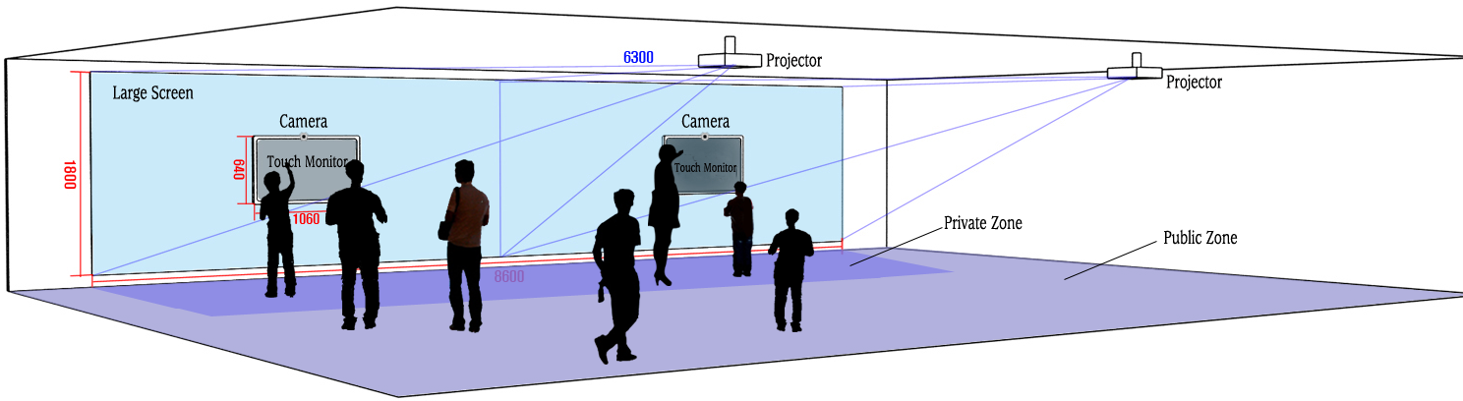
Implementation and application | 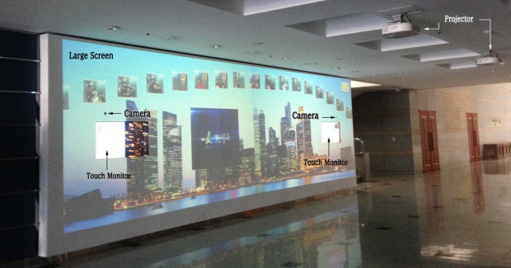

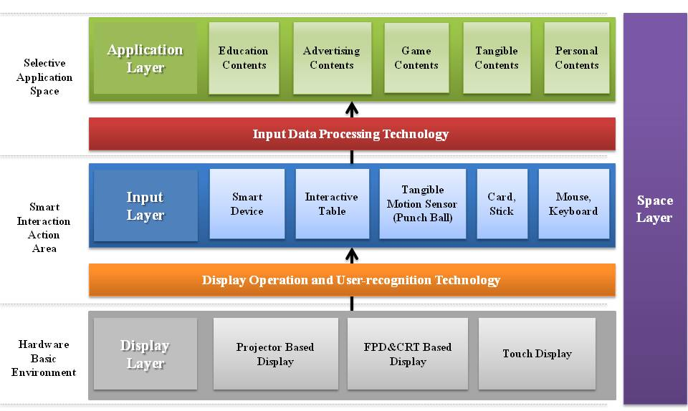
Fig. 1 Interaction Framework Construction.
The application layer to the optional application space is available in a variety of content, depending on user and environment. At this time, the contents are worked and displayed based on the data entered through the input device.

IV. Interaction Design and Implementation

In this paper, we design and implement the interaction system and interface by focusing the interaction framework based around of technologies in reality and virtual space. We will be developed for each specific space systems and interfaces after classifying the action in real space and virtual space. As shown in Table2, system that can be applied in the real environment are designed in such a way that the user interact directly with most based on the project. Smart Interaction content platform[11] will be photographing and transport users in ambient intelligent environment. It also provides a variety of forms of digital content by means of the effective information transmission and games, advertising interface through the touch interaction. Smart interaction content platform includes the screen using the wall, a touch monitor or a projector, a camera for pickup the image and check the user of the status.
As shown in Table3, system that can be applied in a virtual environment to the system are the AR-based shape, but the design is based on the most LCD. Most systems are designed and developed in a manner that provides an enhanced display through the projector. Space-based augmented reality gaming systems [12] uses Spatial Augmented Reality(SAR) technology that is the latest issues in order to provide a more immersive display gaming environment. SAR provides a more realistic image to the user by mixing the real world with virtual objects without special equipment. That is, it provides a more realistic gaming experience by type linked to the actual living things in the game environment.

V. Conclusion
Interaction paradigm has been centered around the made around the device, computing environment and human. Recently, techniques of interaction in ubiquitous computing environment have continued to develop user-friendly input method. In this paper, we approached the way of the space-centric interaction such as paradigm of the new form. Therefore, we proposed the space-centric interaction by analyzing the interaction ecosystem through the organic relationship between the properties of the interaction in the ambient intelligence environment. That is, it has provided a variety of techniques in the interaction space. And then we divided into a real space and a virtual space through the space-centric design.
Users and designers can easily design by providing a spatial interaction patterns. It made users easy to design by supplying space based interaction pattern in correlation of each elements in the interaction space. By analysis in model based patterns, it suggested an efficient interaction environment and an guideline to designers a simple interaction environmental designing. In this paper, the users get desired information in ease by supplying suitable space based interaction environment in smart interaction. In various interaction ways, this kind of smart interaction make users to get information easily by focusing on the spaces not on the input devices, then user could make human affinity interaction in the space. In other words, it supplies smart interaction system to users by space based designing.

References

[1] Kim, L., Cho, H., & Park, S., “SmartPuck System: Tangible Interface for Physical Manipulation of Digital Information”, Journal of KISS, 34(4), pp.226~230, 2007.
TABLE 3
Virtual space(Agumented Reality) Environment
Applied Technology | CRT-based semi-transparent mirror display technology
Design and concept | 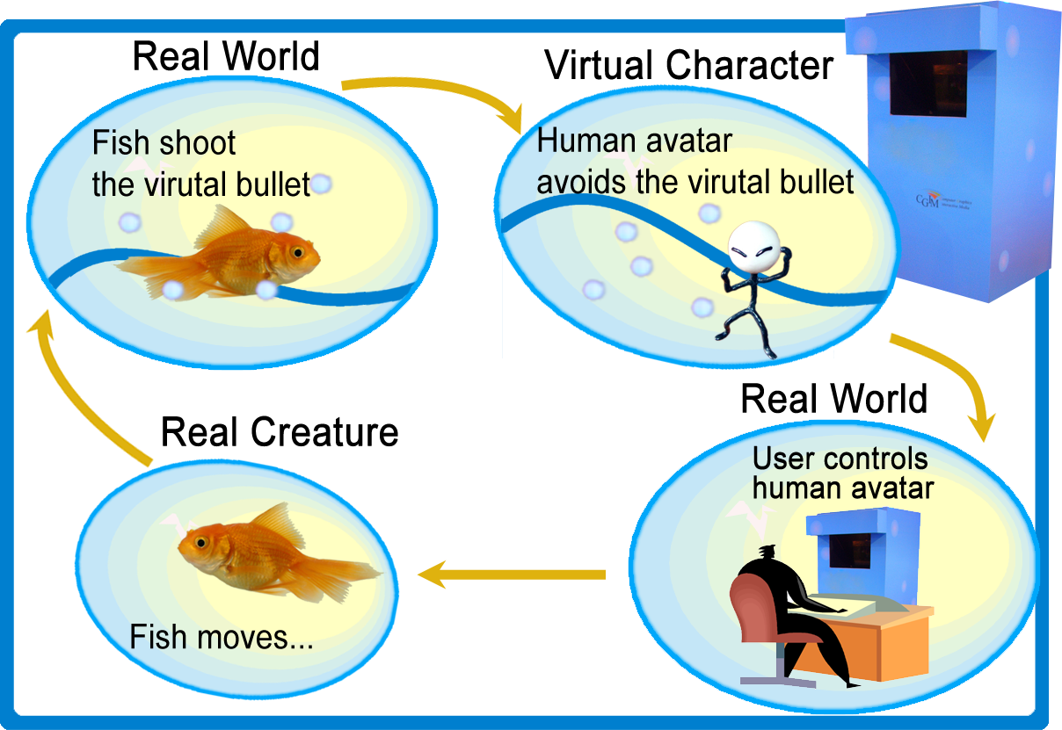
Implementation and application | 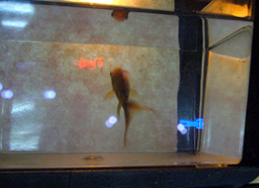

- Ganser, C., Steinemann, A., & Hofer, R., “Infractables: Supporting collocated group work by combining pen-based and tangible interaction”, IEEE, 2007.
- Han, J. Y., “Low-cost multi-touch sensing through frustrated total internal reflection”, In Proceedings of the 18th annual ACM symposium on User interface software and technology, ACM, pp.115~118, 2005.
- Microsoft Surface, http://www.microsoft.com/surface.
- Rekimoto, J., & Saitoh, M., “Augmented surfaces: a spatially continuous work space for hybrid computing environments”, In Proceedings of the SIGCHI conference on Human Factors in Computing Systems, ACM, pp.378~385, 1999.
- Raskar, R., Welch, G., Cutts, M., Lake, A., Stesin, L., & Fuchs, H., “The office of the future: A unified approach to image-based modeling and spatially immersive displays”, In Proceedings of the 25th annual conference on Computer graphics and interactive techniques, ACM, pp.179~188, 1998.
- Johanson, B., Fox, A., & Winograd, T., “The Interactive Workspaces Project: Experiences with Ubiquitous Computing Rooms [Version# 2, 4/11/02]”, 2002.
- Russell, D. M., Streitz, N. A., & Winograd, T., “Building disappearing computers”, Communications of the ACM, 48(3), pp.42~48, 2005.
- Choi, S., Jung, J., and Seo, Y., Technology Trend and Application for Tabletop Device and Interactive Wall Display, Communications of the KISS, KISS, 26(3), pp.5~14, 2008.
- Milgram, P., & Kishino, F., “A taxonomy of mixed reality visual displays”, IEICE TRANSACTIONS on Information and Systems, 77(12), pp.1321~1329, 1994.
- Yun, C. O., Yun, T. S. and Lee, D. H., “Spatial Interaction System for Providing Interactive Zone in Large-Scale Display Environment”, 12th International conference, HCI International 2009, San Diego, CA, USA, pp.132~136, 2009.
- Yun, C. O., Kim, J. H., Yun, T. S., and Lee, D. H., “Development of Game Environment System based on Spatial Augmented Reality using Real Creature”, Journal of Korea Multimedia Society, Vol.12, No.6. pp.856~866, 2009.

